
Classroom Physical Activity Planning Template
For Strategies 4 through 8

Instructions:

Step 1
Column 1 lists the two primary approaches to
classroom physical activity, as well as additional opportunities to add classroom physical activity. You should have ready-to-use activities for all of these approaches and opportunities. If you are just getting started, identify at least one way that you will focus on to integrate physical activity into the classroom.
Step 2
For each approach or opportunity, go to Springboard
to Active School’s Online Platform: Integrate Classroom Physical Activity in Schools. Use the resources listed in Strategy 4 on this website to identify at least one new activity for each approach that you can use in your classroom to increase physical activity. List these activities in Column 2.
Step 3
Identify when you will integrate each activity into
your classroom. For ideas, see Online Platform resources under Strategy 5. Put this information in Column 3.
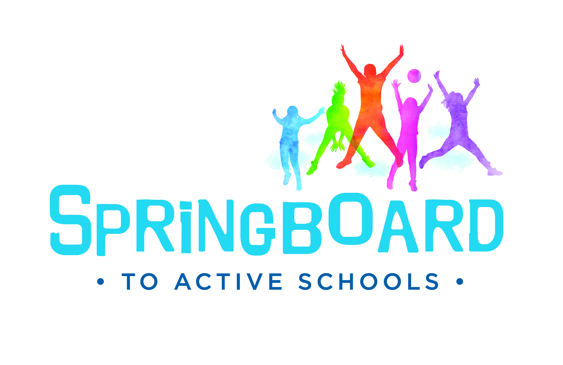
Step 4
Springboard to Active Schools is an initiative of the National Network of Public Health Institutes (NNPHI) and Health Resources in Action (HRiA) through Cooperative Agreement CDC-RFA-DP16-1601 (NU1ADP003094) with the Centers for Disease Control and Prevention (CDC).
www.schoolspringboard.org
Determine whether any equipment, technology, or
additional resources are needed to conduct each activity. Determine how you will get these resources if you do not have them. For ideas, see Online Platform resources under Strategy 6. Put this information in Column 4.
Step 5
Determine what type of space is needed for each
activity and if an alternative classroom setup or alternative spaces are needed. For ideas, see Online Platform resources under Strategy 7. Put this information in Column 5.
Step 6
List any considerations that you should keep in
mind to promote the safety, behavior management, and inclusion of all students. For ideas, see Online Platform resources under Strategy 8. Put this information in Column 6.

Classroom Physical Activity Planning Template

What activities can be used to adopt, promote, enhance, and sustain classroom physical activity?
APPROACHES TO INTEGRATE ACTIVITIES  (Strategy 4) | NAME & DESCRIPTION OF ACTIVITIES | APPROPRIATE TIME FOR ACTIVITIES  (Strategy 5) | EQUIPMENT, TECHNOLOGY, & RESOURCES REQUIRED  (Strategy 6) | SPACE REQUIREMENTS  (Strategy 7) | SAFETY, BEHAVIORAL, & INCLUSION CONSIDERATIONS  (Strategy 8)
EXAMPLE:  Activities to integrate physical activity into planned academic instruction | TOSS AND CATCH:  Partners toss an object back and forth for each letter of a spelling word until the word is spelled out | After lunch at the start of the spelling lesson | Any soft object | Pairs can spread out and throw an object across desks, in the aisle, or around a reading circle | To accommodate different levels of skill and abilities, student pairs can choose to either stand or sit while tossing an object back and forth.
Activities to integrate physical activity into planned academic instruction
Activities to integrate physical activity outside of planned academic instruction
Activities to
re-energize a class
Activities to improve student behavior and classroom climate
Activities to
re-engage the class after a school break
Ways to leverage schoolwide opportunities to promote classroom physical activity approaches
Springboard to Active Schools is an initiative of the National Network of Public Health Institutes (NNPHI) and Health Resources in Action (HRiA) through Cooperative Agreement CDC-RFA-DP16-1601 (NU1ADP003094) with the Centers for Disease Control and Prevention (CDC).
www.schoolspringboard.org

