
Information Collection and Sharing Planning Template

Instructions:
- Identify what information you want to know and why, and then consider what information can be feasibly collected by teachers and/or others on classroom physical activity efforts.
- Outline a plan to collect information (Information Identification and Collection Plan template) and share your successes, challenges, and lessons learned (Share What You Learned template).

Information Identification and Collection Plan

TYPE OF INFORMATION | METHOD OF COLLECTION | FREQUENCY OF COLLECTION OR DOCUMENTATION | WHO WILL COLLECT THE DATA?
Sample:  Student activity levels during class. | Number of steps via pedometer. | Students track steps during class period, recorded at end of class. | Students record and calculate totals.
Type of classroom physical activity (e.g., approach, preparation time, ease, student enjoyment, length of activity)
Frequency (e.g., minutes, number of times in a class period, week, etc.) of classroom physical activity
Effect on student behavior (e.g., teacher observations, trends
in the number of disciplinary issues, etc.)
Effect on students’ academic performance (e.g., teacher observations, trends in academic performance, etc.)
Other:
Other:

Share What You Learned

AUDIENCE | PURPOSE OF COMMUNICATION | WHAT WILL BE COMMUNICATED | MODE AND FREQUENCY OF COMMUNICATION
Sample:  Parents | Encourage parents to be physical activity advocates. | Effect of increased student physical activity on behavior and academics. | Quarterly during PTA meetings and via email.
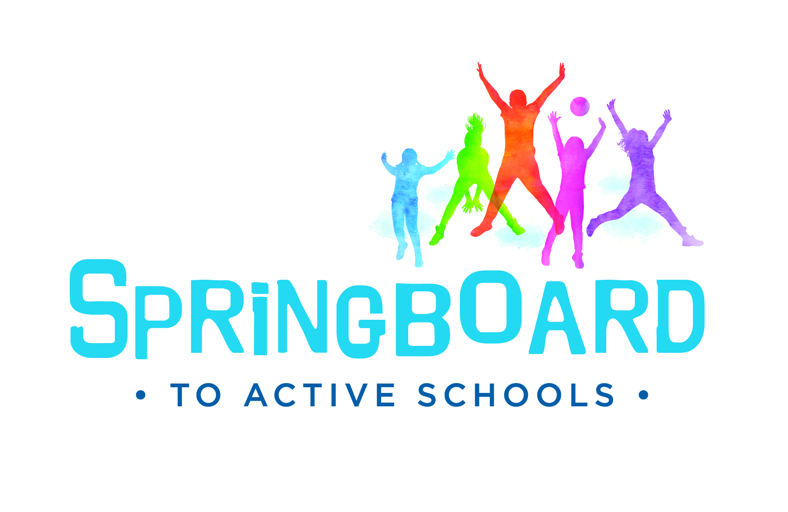
Springboard to Active Schools is an initiative of the National Network of Public Health Institutes (NNPHI) and Health Resources in Action (HRiA) through Cooperative Agreement CDC-RFA-DP16-1601 (NU1ADP003094) with the Centers for Disease Control and Prevention (CDC).
www.schoolspringboard.org

